EXPERIMENT NO:7
AIM: Configure a network and Implement OSPF Routing.
TOOLS/SOFTWARES REQUIRED: Cisco Packet tracer
THEORY:
Open Shortest Path First (OSPF) is a dynamic, link-state routing protocol used to exchange routing information between routers in an IP network. It is standardized by the Internet Engineering Task Force and is commonly implemented in network simulation tools like Cisco Packet Tracer for learning and experimentation.
In Cisco Packet Tracer, OSPF is used to simulate real-world routing behavior between multiple routers. Each router discovers its neighbors and exchanges routing information using Link-State Advertisements (LSAs). These LSAs help routers build a Link-State Database (LSDB) that represents the entire network topology.
OSPF uses the Dijkstra’s Algorithm, also known as the Shortest Path First (SPF) algorithm, to calculate the best and shortest path to reach a destination network. The path selection is based on a metric called cost, which depends on the bandwidth of the links.
In the simulation, routers are configured under an OSPF process using commands such as router ospf and network. Each network is assigned to an area, typically Area 0 (backbone area) in small lab setups.
Routers form neighbor relationships by exchanging Hello packets. Once adjacency is established, they synchronize their routing tables and maintain communication using periodic updates.

OUTPUT
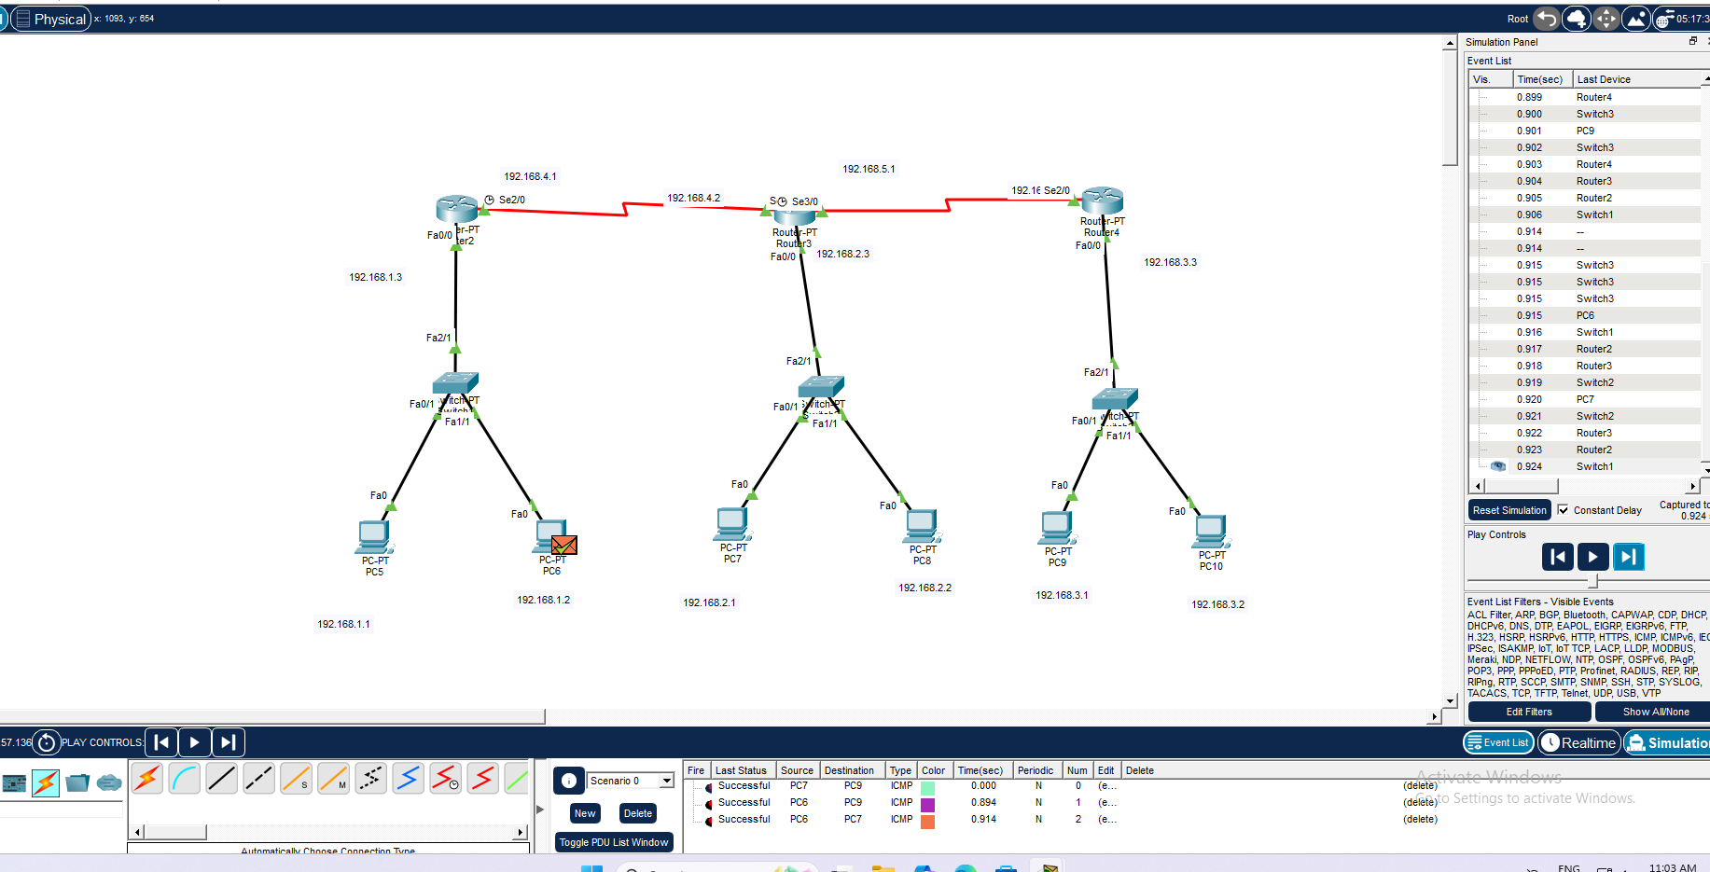
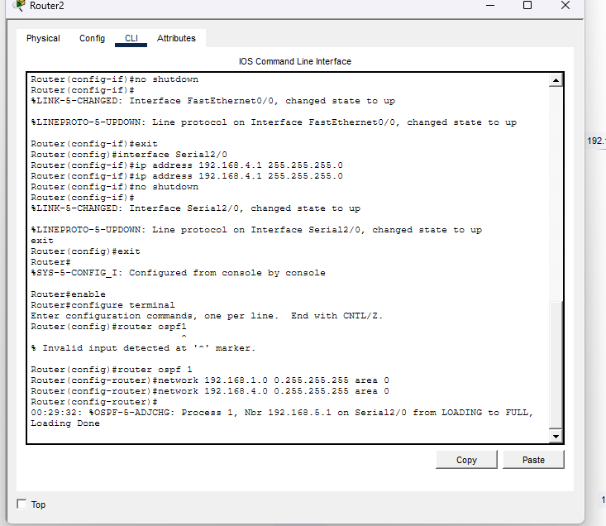
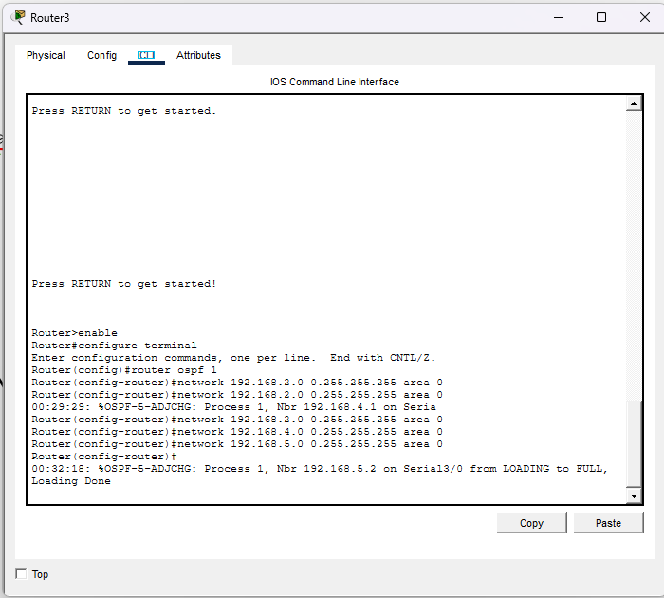
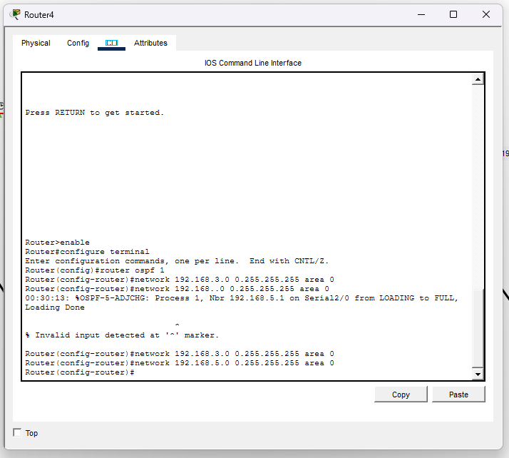

CONCLUSION
The implementation of the Open Shortest Path First (OSPF) routing protocol was successfully carried out using Cisco Packet Tracer. The experiment demonstrated how routers dynamically exchange routing information and establish neighbor relationships within the network.

